Khoa Thanh Nguyen, Huong Phan

Bioinformatics - Module 2 Capstone Paper

The effect of different magnesium concentration levels on species richness and relative abundance of Gram positive and Gram negative bacteria

1. **Introduction**

Magnesium has been long proposed as one of the essential chemical for the life of bacteria. Early studies showed that the change in magnesium level may exert a substantial effect on the cellular division of some bacteria, especially in the final stage of cellular division (Webb, 1953). It was found that an excessive or insufficient amount of magnesium may lead to failure of cellular division in final stage. Besides, a reduction in level of magnesium content was associated with a reduction in the amount of amino acids assimilation and consequently a decrease in amino acid concentration within cells. Decreased levels of amino acids would be lethal for the cells, as it slows down the rate of protein synthesis, including proteins essential for cellular growth (Webb, 1953). Magnesium also plays a role in phosphorylation in the bacterial cells, including in the absence of DNA. In a study, magnesium chloride was added into a culture of *A. faccalis* before and after centrifugationto observe the activities of oxidative phosphorylation. Addition of magnesium chloride before centrifugation activates phosphorylation, and omission of magnesium results in loss of activity. Also, addition of magnesium chloride after the centrifugation process recovers the phosphorylation activities in the pellets of bacteria. Increased amount of addition of magnesium leads to more activity in the pellets of bacteria. (Shibko & Pinchot, 1961). Earlier studies also showed the role of magnesium in mitochondrial activities. (Linnane & Ziegler, 1958).

There is also a difference between the importance of magnesium between Gram positive and Gram negative bacteria. The amount of magnesium required by Gram-positive bacteria can be as ten times greater than the amount required by Gram-negative organisms in the same conditions. (Webb, 1953). Webb showed that in general, Gram-positive bacteria fail to grow when magnesium content is less than .6 ppm, but this level of magnesium is enough to maintain growth for Gram-negative bacteria.

In this paper, we studied the effect of magnesium concentration in soil on bacterial richness in two distinct communities, crop and forest. Our hypothesis was that there were significantly more species richness and relative abundance of gram-positive bacteria and gram-negative bacteria in places with higher magnesium concentration within crop samples, forest samples and across all samples. Since there had been evidences that gram-positive bacteria are more dependent on magnesium than gram-negative bacteria, we hypothesized that the correlation with magnesium concentration was more significant in gram-positive bacteria than gram-negative bacteria.

1. **Methodology**
2. Experiment design

An experiment to investigate the effect of soil tillage on microbial communities in different site of disturbance was conducted in 2014 by a group of faculty and students at Earlham College. They chose two sites with very different history of disturbance: a heavily tilled agricultural field and a mature forest, both owned by Earlham College. Ten 1m2 plots were chosen in each site and five plots in each site were randomly chosen to be tilled, the other five were not tilled.

1. DNA sequencing and data processing

All soil samples from each plot were subjected to chemical analysis before tilling. DNA from each sample was extracted and sequenced pre-treatment, 1 day post-treatment and 10-days post-treatment.

16 rRNA amplicons libraries of region V4 were mapped from the DNA extracted and the sequences were amplified using the 515F and 806R primer set for bacteria. Amplicon libraries were combined at equimolar ratios and the combined set of samples was sequenced at the Center for Genomics and Bioinformatics at IU-Bloomington on the Illumina MiSeq platform using 150 bp paired-end sequencing.

For this paper, we process 20 pre-treatment samples of 16 rRNA sequences using the mothur workflow created by the Schloss lab (Kozich, Westcott, Baxter, Highlander, & Schloss, 2013), the standard operating procedure to process 16S rRNA gene sequences generated using Illumina's MiSeq platform using paired end reads. Operational taxonomic units used in our analysis are based on 97% identity.

1. Statistical analyses

The files used in our statistical analyses include the soil chemical data of 20 pre-treatment crop and forest samples, and the taxonomy summary of bacteria in terms operational taxonomic units found in all sequences. In our analyses, we chose Actinobacteria and Firmicutes as two Gram positive phyla of bacteria, Proteobacteria and Actinobacteria as two Gram negative phyla of bacteria. We used R to do our analyses (R Core Team, 2018) on the correlation of relative abundance and richness of different phyla of bacteria with magnesium concentration. We examined the correlation of relative abundance and richness of different phyla of bacteria with magnesium concentration within crop and forest samples and across all samples. To do this, we used the ggplot function in ggplot2 package (Wickham, 2016) to draw a series of scatter plots and fit linear regression models of relative abundance of phyla against magnesium concentration. The “summary” function in R was used to examine the significance of the correlation, at 5% level of significance (adjusted p < 0.05).

1. **Results**
2. Relative abundance of phyla dependent on magnesium concentration across crop and forest fields

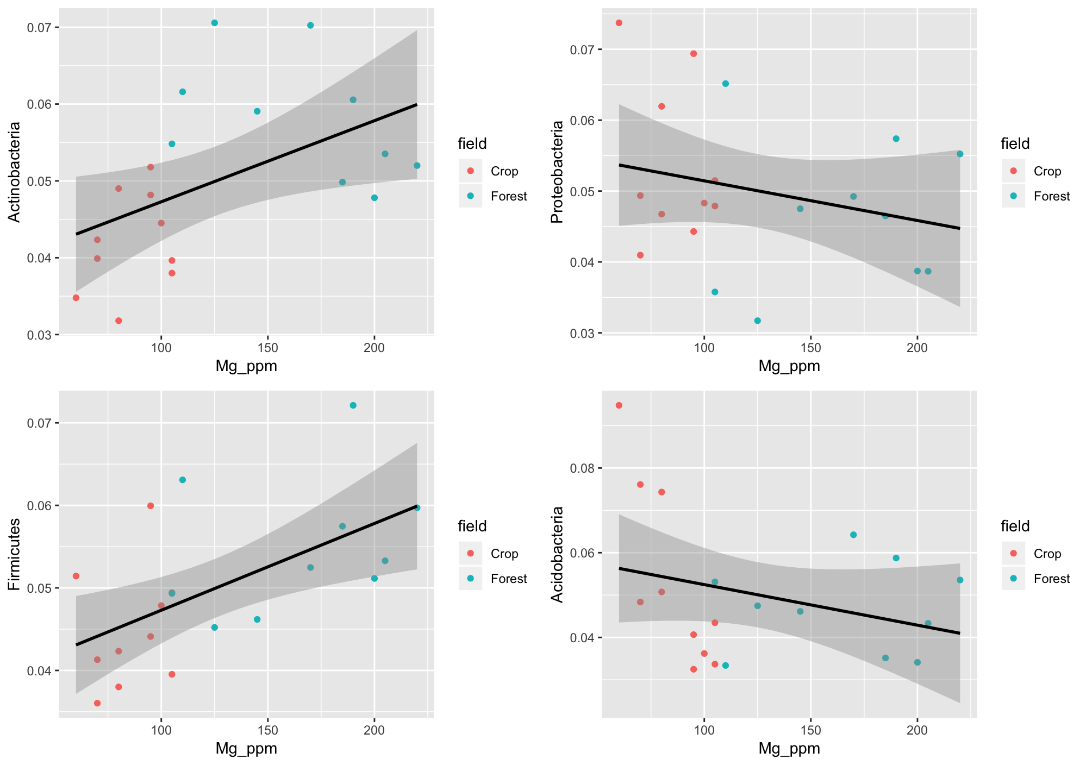

Figure 1. Scatter plots of **relative abundance** of different phyla of bacteria against magnesium concentration (in ppm). The graphs on the left side features the weak linear positive relationship between **relative abundance** of two **Gram positive** phyla of bacteria, Actinobacteria and Firmicutes, with magnesium concentration. The graphs on the right side features the weak linear negative relationship between **relative abundance** of two **Gram negative** phyla of bacteria, Proteobacteria and Acidobacteria, with magnesium concentration.

The first relationship we examined is relationship between relative abundance of four different phyla of bacteria (Actinobacteria and Firmicutes as gram-positive and Proteobacteria and Acidobacteria as gram-negative) and magnesium concentration. Using the statistical analysis from R Studio, we were able to build scatter plot on the relationship between magnesium concentration across crop and forest samples and the relative abundance of bacteria. For Actinobacteria, a gram-negative phyla, we observed a non-significant correlation between abundance and magnesium concentration among crop samples (p = 0.3765, F1,8 = 0.8769), a non-significant correlation among forest samples (p = 0.1559, F1,8 = 2.453). For Proteobacteria, a gram-negative phyla, we observed a non-significant correlation among crop samples (p = 0.4572, F1,8 = 0.6101), a non-significant correlation among forest samples (p = 0.7971, F1,8 = 0.07). For Firmicutes, a gram-positive phyla, we observed a non-significant correlation among crop samples (p = 0.5263, F1,8 = 0.4389), a non-significant correlation among forest samples (p = 0.3707, F1,8 = 0.8995). For Acidobacteria, a gram-negative phyla, we observed a significant negative correlation among crop samples (p = 0.00274, F1,8 = 18.2), and a non-significant correlation among forest samples (p = 0.8432, F1,8 = 0.04173).

The results for relationship between all samples and magnesium concentration were different from within crop and forest samples. For Actinobacteria, there was a significant positive relationship (p = 0.02528, F1,18 = 5.952). For Proteobacteria, there was a non-significant relationship (p = 0.2734, F1,18 = 1.276). For Firmicutes, there was a significant negative relationship (p = 0.006585, F1,18 = 9.43). For Acidobacteria, there was a non-significant relationship (p = 0.2104, F1,18 = 1.687).

1. Richness of phyla dependent on magnesium concentration across crop and forest fields

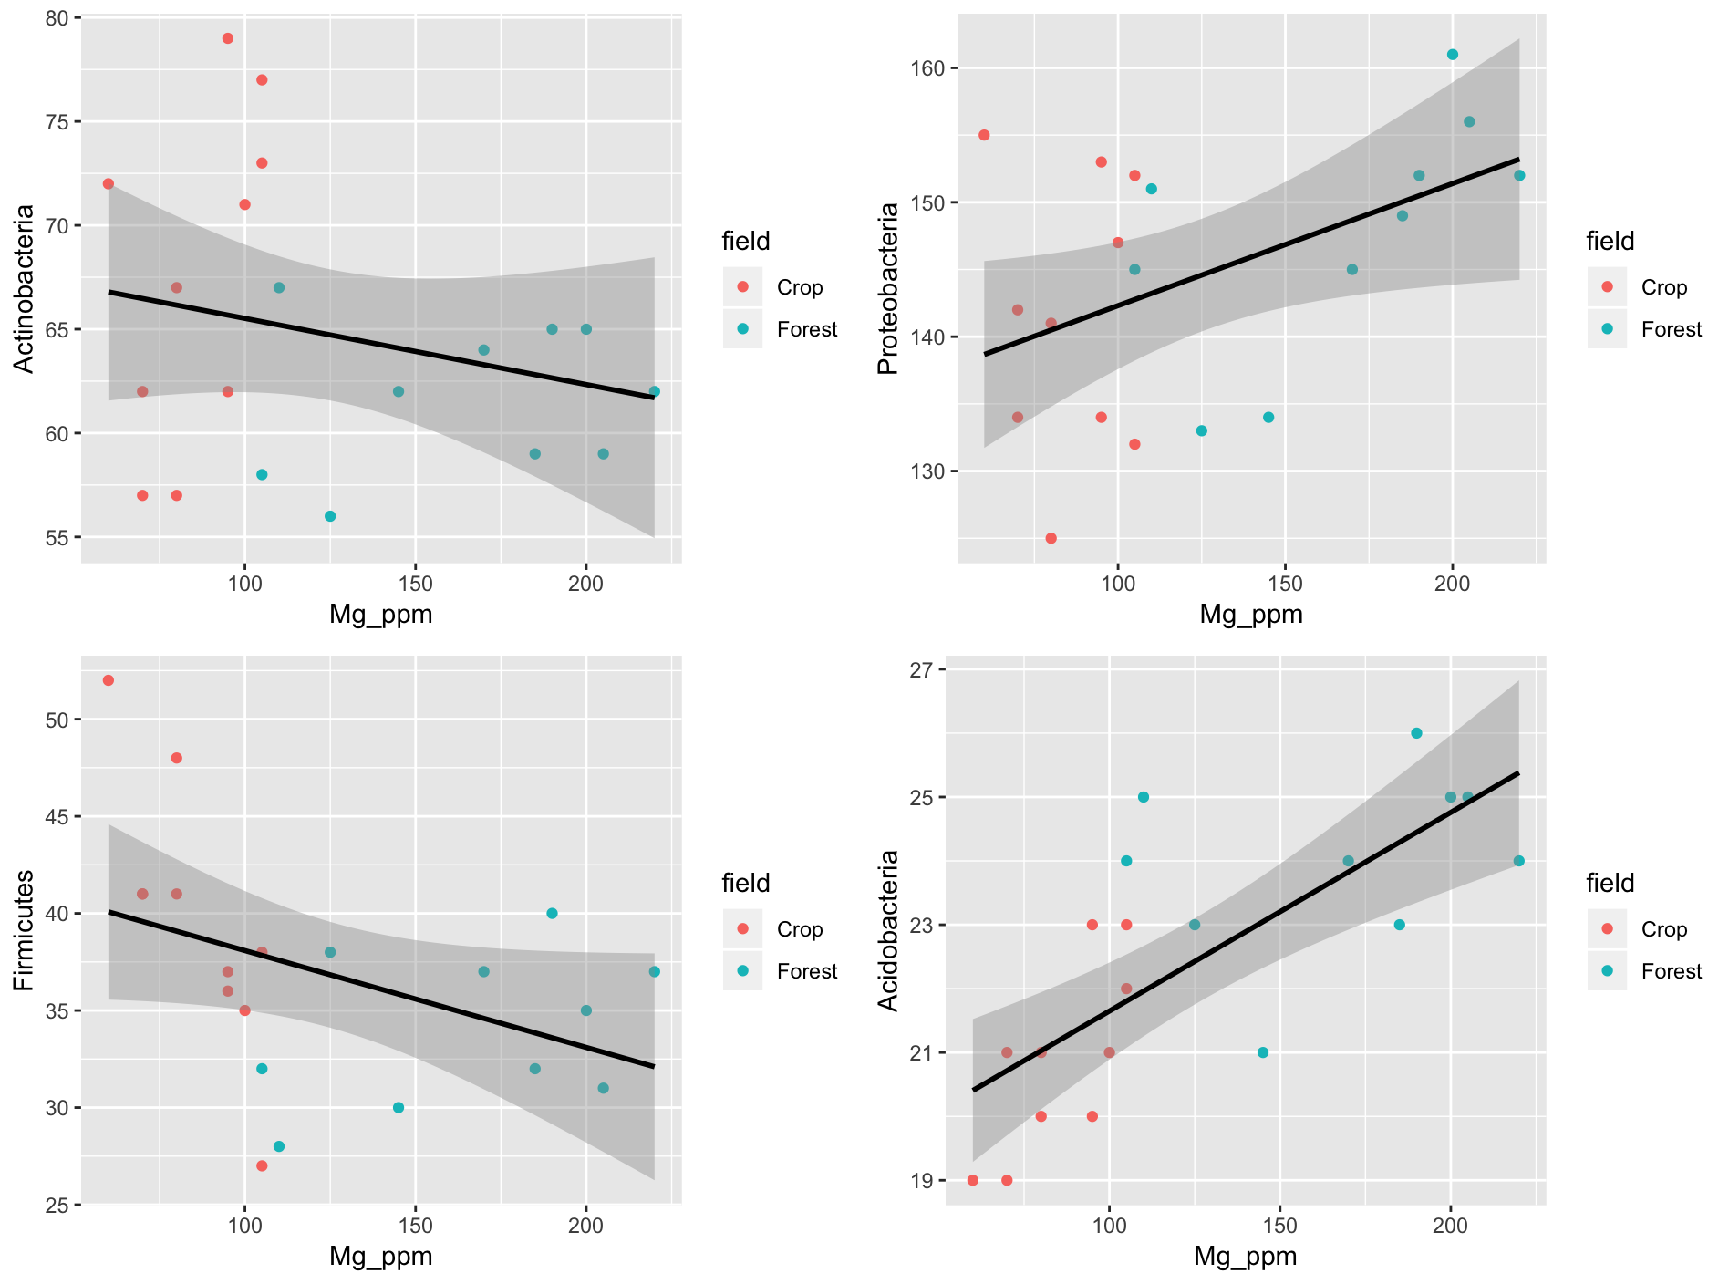

Figure 2. Scatter plots of **richness** of different phyla of bacteria against magnesium concentration (in ppm). The graphs of left side features the weak linear negative relationship between **richness** of two **Gram positive** phyla of bacteria, Actinobacteria and Firmicutes, with magnesium concentration. The graphs of right side features the weak linear positive relationship between **richness** of two **Gram negative** phyla of bacteria, Proteobacteria and Acidobacteria, with magnesium concentration.

The second relationship we examined is relationship between species richness of four different phyla of bacteria (Actinobacteria and Firmicutes as gram-positive and Proteobacteria and Acidobacteria as gram-negative) and magnesium concentration. For Actinobacteria, we observed a non-significant correlation among crop samples (p = 0.1275, F1,8 = 2.891), a non-significant correlation among forest samples (p = 0.6562, F1,8 = 0.2136), and a non-significant correlation among all samples (p = 0.3055, F1,18 = 1.112). For Proteobacteria, we observed a non-significant correlation among crop samples (p = 0.9926, F1,8 = 9.185e-05), a non-significant correlation among forest samples (p = 0.06685, F1,8 = 4.494), and a significant positive correlation among all samples (p = 0.0613, F1,18 = 5.128) For Firmicutes, we observed a significant positive correlation among crop samples (p = 0.004394, F1,8 = 15.4), a non-significant correlation among forest samples (p = 0.2652, F1,8= 1.436), and a non-significant correlation among all samples (p = 0.072, F1,8 = 3.654). For Acidobacteria, we observed a significant positive correlation among crop samples (p = 0.01404, F1,8  = 9.788), a non-significant positive correlation among forest samples (p = 0.4269, F1,8 = 0.7006), and a significant positive correlation among all samples (p = 0.0001382, F1,18 = 23.2).

1. **Discussion**

We initially hypothesized that there will be a significantly positive correlation between species richness and relative abundance of both gram-positive and gram-negative bacteria to magnesium concentration across both crop and forest samples. Besides, with evidences that gram-positive bacteria are more dependent on magnesium than gram-negative bacteria, we predict that this correlation is more significant in gram-positive bacteria than in gram-negative bacteria. We test our hypothesis using four types of bacteria (Actinobacteria and Firmicutes as gram-positive and Proteobacteria and Acidobacteria as gram-negative).

Within crop and forest samples themselves, the result for the relationship between relative abundance and magnesium concentration only proves to be significantly negative for Acidobacteria in crop samples. This result goes against our initial hypothesis that relative abundance correlates positively with magnesium concentration. However we do not observe any significant relationship in other species.

The contradiction to our initial hypothesis found in relative abundance of Acidobacteria’s negative correlation with magnesium concentration can be explained in multiple ways. First of all, the relative abundance of Acidobacteria might be affected by other factors in soil as well, not just magnesium. These factors includes soil acidity, available potassium, organic matter content, calcium etc. Thus, all of these factors might be at play and obscure the relationship between magnesium and bacterial relative abundance. To properly observe the relationship between magnesium concentration and bacterial relative abundance, we need to control other interfering factors. The alternative explanation, however, comes from a recent study, in which it is found that Acidobacterium indeed negatively correlates with pH, catalase activity, as well as exchangeable calcium and magnesium. (Chen et al., 2019). If this is the case, then our result confirms the recent study and goes against the previous studies. Chen et al. 2019 also found the the relative abundance of Proteobacteria was greater in rhizosphere soil of poorly-performing plants when Acidobacteria were found more popular in non-rhizosphere of poorly-performing plants, and Actinobacteria were more abundant in rhizosphere of healthy plants.

However, within all forest and crop samples, we observed significant positive relationship in Actinobacteria and Firmicutes, confirming our hypothesis. This agrees with previous results stating that availability of magnesium is one of the most strongly associated factors with bacterial community composition (Tu et al., 2018; Jeanbille et al., 2016).

For species richness, we observed a significantly positive correlation among all samples in Proteobacteria and Acidobacteria, and a significantly positive correlation among crop samples in Firmicutes and in Acidobacteria. All of these observations confirm our hypothesis that there is higher bacterial richness with higher magnesium concentration. In particular, the correlation among Acidobacteria seems to be the strongest. This result attests to previous findings that Acidobacteria are significantly more abundance in forest than in agricultural soil. (Chim Chan et al., 2008). On the other hand, Proteobacteria has been found to be less sensitive to changes in magnesium concentration than Acidobacteria. We do not find any correlations for Firmicutes, but previous studies suggested that Firmicutes may be responsive for other factors such as carbon inputs. However, the study also acknowledged that the mechanism in which Firmicutes become dominant requires further studies (Tu et al., 2018).

After collecting our results and looking at our results in the context of other studies, we found that our results for the most part agreed with the previous studies. Nevertheless, we found significant correlations in several species, in which previous studies have been either elusive or arguable, such as the negatively significant correlation between Acidobacteria relative abundance and magnesium concentration. To better carry out experiments for the future to study the relationship between magnesium and bacterial diversity, we might need better control of other factors in soils, and a more representative pool of samples.

**References**

Chim Chan, O., Casper, P., Sha, L. Q., Feng, Z. L., Fu, Y., Yang, X. D., ... & Zou, X. M. Vegetation cover of forest, shrub and pasture strongly influences soil bacterial community structure as revealed by 16S rRNA gene T-RFLP analysis. *FEMS microbiology ecology*, vol. 64, no. 3, 2008, pp. 449-458.

Chen, S., Zhu, Y., Shao, T., Long, X., Gao, X., & Zhou, Z. Relationship between rhizosphere soil properties and disease severity in highbush blueberry (Vaccinium corymbosum). *Applied Soil Ecology*, 2019.

Jeanbille, M., Buee, M., Bach, C., Cebron, A., Frey-Klett, P., Turpault, M. P., & Uroz, S. Soil parameters drive the structure, diversity and metabolic potentials of the bacterial communities across temperate beech forest soil sequences. *Microbial ecology*, vol. 71, no. 2, 2016, pp. 482-493.

Hope, Ryan M. *Rmisc: Rmisc: Ryan Miscellaneous*. R package version 1.5., 2013, [https://CRAN.R-project.org/package=Rmi](https://cran.r-project.org/package=Rmisc)sc

Kozich, J. J., Westcott, S. L., Baxter, N. T., Highlander, S. K., and P. D. Schloss. Development of a dual‐index sequencing strategy and curation pipeline for analyzing amplicon sequence data on the MiSeq Illumina sequencing platform. *Applied and Environment Microbiology*, vol. 79, 2013, pp. 5112–5120.

Linnane, A. W., and D. M. Ziegler. "Studies on the mechanism of oxidative phosphorylation V. the phosphorylating properties of the electron transport particle." *Biochimica et biophysica acta* vol. 29, no. 3, 1958, pp. 630-638.

R Core Team. *R: A language and environment for statistical computing.* R

Foundation for Statistical Computing, Vienna, Austria, 2018, [https://www.R-project.org](https://www.r-project.org/)

Shibko, S., and Gifford B. Pinchot. "The effects of magnesium and polyanions on oxidative phosphorylation in bacteria." *Archives of Biochemistry and Biophysics* vol. 93, no. 1, 1961, pp. 140-146.

Tu, J., Qiao, J., Zhu, Z., Li, P., & Wu, L. Soil bacterial community responses to long-term fertilizer treatments in Paulownia plantations in subtropical China. *Applied Soil Ecology*, vol. 124, 2018, pp. 317-326.

Webb, M. “Effects of Magnesium on Cellular Division in Bacteria.” *Science*, vol. 118, no. 3073, 1953, pp. 607–611.

Wickham, H. *ggplot2: Elegant Graphics for Data Analysis.* Springer-Verlag New York, 2016.